浙江大学2005–2006学年秋季学期
《计算机网络》课程期末考试试卷
开课学院：软件学院， 考试形式：闭卷
考试时间：_____年____月____日, 所需时间：120分钟
考生姓名： ___学号： 专业： 得分：
答案：
题号 | 答 案 |  |  |  |  |  |  |  |  |  | 得分
1-10
11-20
21-30
31-40
41-50
51-60
61-70
71-80
81-90
91-100

For every following question, please select your best answer only!!!

- The transmission unit for the physical layer is a/an __________.
  - packet
  - frame
  - bit
  - byte

- Which best describes the structure of an encapsulated data packet?
  - Segment header, network header, data, frame trailer
  - Segment header, network header, data, segment trailer
  - Frame header, network header, data, frame trailer
  - Frame header, segment header, data, segment trailer

- The communication subnet consists of __________.
  - physical layer, data link layer, and network layer
  - physical layer, network layer, transport layer
  - physical layer, data link layer, network layer, transport layer
  - data link layer, network layer, transport layer, session layer

- Which of the following statements best describes a WAN?
  - It connects LANs that are separated by a large geographic area.
  - It connects workstations, terminals, and other devices in a metropolitan area.
  - It connects LANs within a large building.
  - It connects workstations, terminals, and other devices within a building.

- Which is the movement of data through layers?
  - Wrapping
  - Encapsulation
  - Traveling
  - Transmission

- Which is the OSI model?
  - A conceptual framework that specifies how information travels through networks.
  - A model that describes how data make its way from one application program to another throughout a network.
  - A conceptual framework that specifies which network functions occur at each layer
  - All of the above

- Which of the OSI layers divides the transmitted bit stream into frames?
  - Physical layer
  - Data link layer
  - Network layer
  - Transport layer

- Which of the following is incorrect?
  - The OSI model is better the TCP/IP model.
  - The OSI model provides more efficient implementation than the TCP/IP model.
  - The OSI model has more layers than the TCP/IP model.
  - The OSI model makes the distinction between services, interfaces, protocols.

- In the TCP/IP model, which layer deals with reliability, flow control, and error correction?
  - Application
  - Transport
  - Internet
  - Network access

- The TCP/IP protocol suite has specifications for which layers of the OSI model?
  - 1 through 3
  - 1 through 4 and 7
  - 3,4,and 5 through 7
  - 1,3,and 4

- A noiseless 4-k Hz channel is sampled every 1 msec. What is the maximum data rate?
  - 8000 bps
  - 4000 bps
  - 1000 bps
  - Can be infinite

- If a binary signal is sent over a 4-k Hz channel, what is the maximum achievable data rate?
  - 8000 bps
  - 4000 bps
  - 1000 bps
  - Can be infinite

- If a binary signal is sent over a 4-k Hz channel whose signal-to-noise ratio is 127:1, what is the maximum achievable data rate?
  - 28000 bps
  - 8000 bps
  - 4000 bps
  - Can be infinite

- A modem constellation diagram has data points at the following coordinates: (1, 1), (1, -1), (-1, 1), and (-1, -1). How many bps can a modem with these parameters achieve at 1200 baud?
  - 1200 bps
  - 2400 bps
  - 4800 bps
  - None of the above

- What is WDM?
  - Multiplexing on fiber-optic cable.
  - Multiplexing using the density of the transmission media.
  - A form of flow control that monitors WAN delays.
  - A form of congestion management for WANs.

- Which technology is not a type of wireless communication?
  - Cellular
  - Broadband
  - Infrared
  - Spread spectrum

- What is one advantage of using fiber optic cable in networks?
  - It is inexpensive.
  - It is easy to install.
  - It is an industry standard and is available at any electronics store
  - It is capable of higher data rates than either coaxial or twisted-pair cable.

- A telephone switch is a kind of __________.
  - packet-switching
  - buffer-switching
  - fabric-switching
  - circuit-switching.

- A cable TV system has 100 commercial channels, all of them alternating programs with advertising. This kind of multiplexing uses ___________.
  - TDM
  - FDM
  - FDM + TDM
  - None of the above.

- A bit string, 01101111101111110, needs to be transmitted at the data link layer. What is the string actually transmitted after bit stuffing (Whenever the sender’s data link layer encounters five consective 1s in the data, it automatically stuffs a 0 bit into the outgoing bit stream)
  - 01101111101111110
  - 0110111110011111010
  - 011011111011111010
  - None of the above

- When DCF (Distributed Coordination Function) is employed, 802.11 uses a protocol called __________.
  - CSMA/CA
  - CSMA/CD
  - ALOHA
  - WDMA

- Which of the following can NOT directly be used for framing?
  - Character count.
  - Flag bytes with byte stuffing.
  - Starting and ending flags, with bit stuffing.
  - Physical layer coding violations.

- Which of the following can a VLAN be considered?
  - Broadcast domain
  - Collision domain
  - Both a broadcast and a collision domain
  - Domain name

- What is the purpose of Spanning Tree Protocol? (Network Bridging)
  - To maintain single loop paths
  - To maintain a loop-free network
  - To maintain a multiloop network
  - To maintain a reduced loop network

- Which uses the twisted pairs?
  - 10Base5.
  - 10Base2.
  - 10Base-F.
  - 10Base-T.

- How do switches learn the addresses of devices that are attached to their ports?
  - Switches get the tables from a router.
  - Switches read the source address of a packet that is entering through a port.
  - Switches exchange address tables with other switches.
  - Switches are not capable of building address tables.

- Repeaters can provide a simple solution for what problem?
  - Too many types of incompatible equipment on the network
  - Too much traffic on a network
  - Too-slow convergence rates
  - Too much distance between nodes or not enough cable.

- Which of the following is true of a switch’s function?
  - Switches increase the size of a collision domains.
  - Switches combine the connectivity of a hub with the capability to filter or flood traffic based on the destination MAC address of the frame.
  - Switches combine the connectivity of a hub with the traffic direction of a router.
  - Switches perform Layer 4 path selection.

- Ethernet MAC addresses are how many bits in length?
  - 12
  - 24
  - 48
  - 64

- What is the information that is “burned in ” to a network interface card?
  - NIC
  - MAC address
  - Hub
  - LAN

- Which connector does UTP (Unshield Twised Pair) use?
  - STP
  - RJ-45
  - RJ-69
  - BNC

- Using repeaters does which of the following to the collision domain?
  - Reduces
  - Has no effect on
  - Extends
  - None of the above

- Which of the following is not a feature of microsegmentation?
  - It enables dedicated access.
  - It supports multiple conversions at any given time.
  - It increases the capacity for each workstation connected to the network.
  - It increases collisions.

- Which of the following protocols would have the highest channel utilization?
  - 0.5-persistent CSMA
  - 1-persistent CSMA
  - Pure ALOHA
  - Slotted ALOHA

- Which of the following is true concerning a bridge and its forwarding decisions?
  - Bridges operate at OSI Layer 2 and use IP addresses to make decisions.
  - Bridges operate at OSI Layer 3 and use IP addresses to make decisions.
  - Bridges operate at OSI Layer 2 and use MAC addresses to make decisions.
  - Bridges operate at OSI Layer 3 and use MAC addresses to make decisions.

- Fast Ethernet supports up to what transfer rate?
  - 5 Mbps
  - 10 Mbps
  - 100 Mbps
  - 1000 Mbps

- Media Access Control refers to what?
  - The state in which a NIC has captured the networking medium and is ready to transmit
  - Rules that govern media capture and release
  - Rules that determine which computer on a shared-medium environment is allowed to transmit the data
  - A formal byte sequence that has been transmitted.

- Which best describes a CSMA/CD network?
  - One node’s transmission traverses the entire network and is received and examined by every node.
  - Signals are sent directly to the destination if the source knows both the MAC and IP addresses
  - One node’s transmission goes to the nearest router, which sends it directly to the destination.
  - Signals always are sent in broadcast mode.

- Which of the following statements about IPv4 header fields is incorrect?
  - An address has 32 bits.
  - The TTL has 4 bits.
  - The version has 4 bits.
  - The identification has 16 bits.

- The subnet mask for a class B network is 255.255.255.192. How many subnetworks are available? (Disregard special addresses)
  - 2
  - 4
  - 1024
  - 192

- Which of the following can be used to connect a keyboard with a computer?
  - 802.3
  - 802.11
  - 802.15
  - 802.16

- Which of the following can be used as the wireless local loop for public switched telephone systems?
  - 802.3
  - 802.11
  - 802.15
  - 802.16

- What is the IP address of the internal loopback?
  - 10.10.10.1
  - 255.255.255.0
  - 127.0.0.1
  - 192.0.0.1

- How does the network layer forward packets from the source to the destination?
  - By using an IP routing table
  - By using ARP responses
  - By referring to a name server
  - By referring to the bridge

- What is one advantage of dynamic routing?
  - Takes little network overhead and reduces network traffic
  - Reduces unauthorized break-ins because security is tight
  - Adjusts automatically to topology or traffic changes
  - Requires little bandwidth to operate efficiently

- Which best describes a default route?
  - Urgent-data route manually entered by a network administrator
  - Route used when part of the network fails
  - Route used when the destination network is not listed explicitly in the routing table
  - Preset shortest path

- What does ICMP stand for?
  - Internal Control Message Portal
  - Internal Control Message Protocol
  - Internet Control Message Portal
  - Internet Control Message Protocol

- What does TTL stand for? (For IP Header fields)
  - Time-To-List
  - Time-To-Live
  - Terminal-To-List
  - Terminal-To-Live

- What is one advantage of distance vector algorithms?
  - They are not likely to count to infinity.
  - You can implement them easily on very large networks.
  - They are not prone to routing loops.
  - They are computationally simple

- Which of the following best describes a link-state algorithm?
  - It recreates the topology of the entire internetwork.
  - It requires numerous computations.
  - It determines distance and direction to any link on the internetwork.
  - It uses litter network overhead and reduces overall traffic.

- What is the minimum number of bits that can be borrowed to form a subnet?
  - 1
  - 2
  - 4
  - None of the above

- In order to find out its IP address, a machine can use __________.
  - ARP
  - RARP
  - ICMP
  - UDP

- Which portion of the Class B address 154.19.2.7 is the network address?
  - 154
  - 154.19
  - 154.19.2
  - 154.19.2.7

- How many host addresses can be used in a Class C network?
  - 253
  - 254
  - 255
  - 256

- Which of the following can NOT be used to traffic shaping?
  - Overprovisioning
  - Leaky bucket algorithm
  - Token bucket algorithm
  - Packet scheduling

- When the congestion is very seriously, which kind of control should be used?
  - Warning bits
  - Load shedding
  - Chocke packets
  - Hop-by-hop chope packets

- Which of the following is most appropriate in order to make the full use of IP addresses?
  - Subneting
  - CIDR
  - NAT
  - All of the above

- How many bits does an IPv6 address have?
  - 32
  - 64
  - 128
  - 256

- Which of the following is true for distance vector routing?
  - Useful for nothing.
  - Used in OSPF
  - Used in BGP
  - None of the above

Given the subnet shown in (a) and the incomplete routing table shown in (b), please use distance vector routing to answer the next 4 questions.
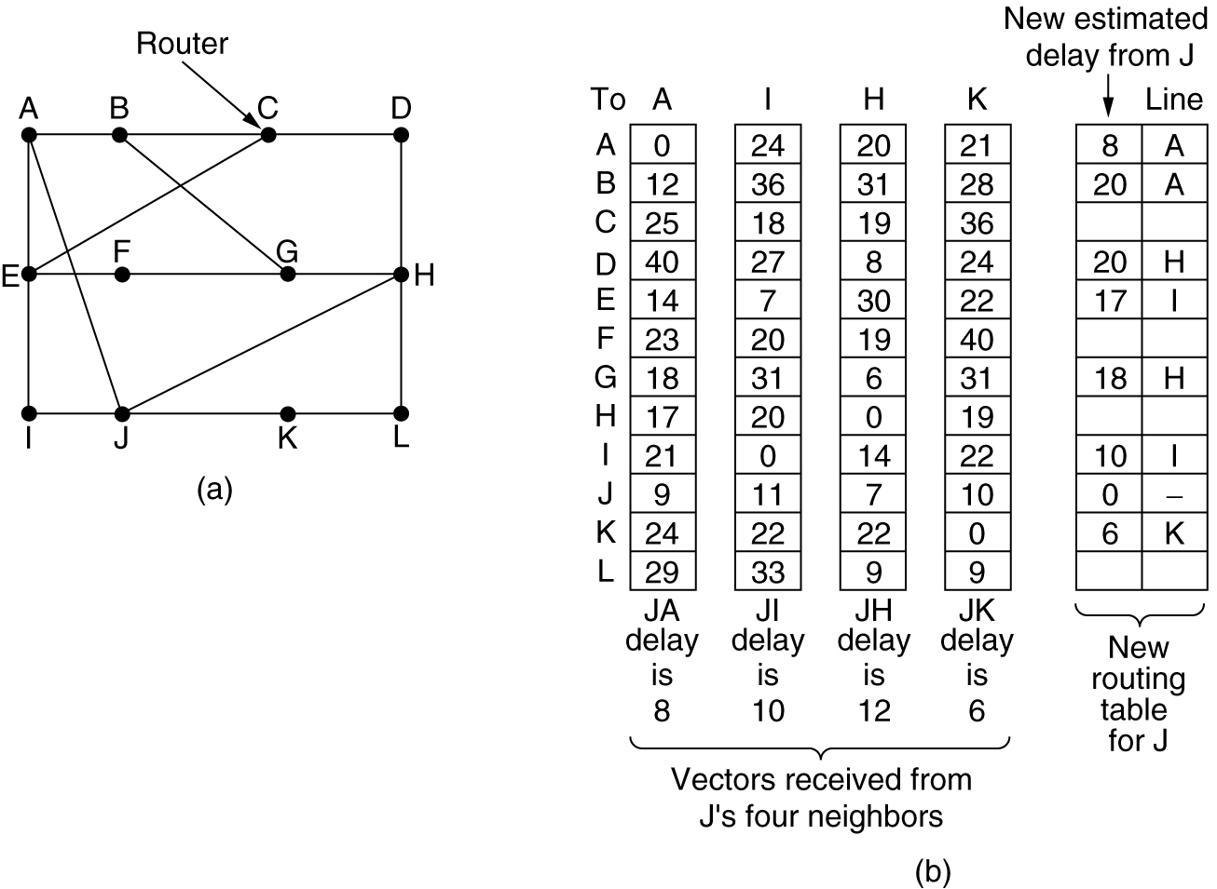

- What is the new distance and next hop for going to C?
  - 28,I
  - 28,A
  - 12,I
  - 12,G

- What is the new distance and next hop for going to F?
  - 30,H
  - 30,I
  - 18,A
  - 18,K

- What is the new distance and next hop for going to H?
  - 0,A
  - 3,I
  - 12,H
  - 18,K

- What is the new distance and next hop for going to L?
  - 6,A
  - 13,I
  - 14,H
  - 15,K

- What does the window field in a TCP segment indicate?
  - Number of 32-bit words in the header
  - Number of the called port
  - Number used to ensure correct sequencing of the arriving data
  - Number of octets that the device is willing to accept

- What do TCP and UDP use to keep track of different conversations crossing a network at the same time?
  - Port numbers
  - IP addresses
  - MAC addresses
  - Route numbers

- Which range of port numbers is unregulated?
  - Below 255
  - Between 256 and 512
  - Between 256 and 1023
  - Above 1023

- Which of the following is incorrect for the TCP header fields?
  - The source port has 16 bits.
  - The URG has just 1 bit.
  - The Window size has 32 bits.
  - The acknowledgement number has 32 bits.

- How does TCP synchronize a connection between the source and the destination before data transmission?
  - Two-way handshake
  - Three-way handshake
  - Four-way handshake
  - None of the above

- What is true for TCP’s retransmission timer?
  - Fixed value to allow 90% of segments arrive without retransmission
  - Fixed value to allow 80% of segments arrive without retransmission
  - Dynamic value based on the past successful transmission history
  - Dynamic value based on the last successful transmission’s RTT

- UDP segments use what protocols to provide reliability?
  - Network layer protocols
  - Application layer protocols
  - Internet protocols
  - Transmission control protocols

- Which of the following is most appropriate?
  - UDP just provides an interface to the IP protocol with the added feature of demultiplexing multiple processes using the ports.
  - UDP can be used to implement RPC.
  - UDP can be used to implement RTP.
  - All of the above.

- Which of the following is a basic service of the transport layer?
  - Provides reliability by using sequence numbers and acknowledgements
  - Segments upper-layer application data
  - Establishes end-to-end operations
  - All of the above

- The TCP primitives depend on __________.
  - both the operating system and the TCP protocol.
  - the operating system only.
  - the TCP protocol only.
  - the operating system and the TCP protocol and the IP protocol.

- The default port for TELNET is __________.
  - 21
  - 22
  - 23
  - 24

- Which of the following is incorrect?
  - DNS stands for Domain Name System.
  - There is only one record associated with every IP.
  - Domain names can be either absolute or relative.
  - Domain names are case insensitive.

- What does MIME stand for?
  - Messages In Multi Encoding
  - Multipurpose Internet Mail Extensions
  - Multipurpose Internet Mail Encoding
  - None of the above

- Which of the following is not a protocol for email?
  - SMTP
  - POP3
  - IMAP
  - GOPHER

- Which of the following is incorrect?
  - HTML stands for HyperText Markup Language.
  - XML stands for eXtensible Markup Language.
  - XHTML stands for eXtended HyperText Markup Language.
  - A browser can display HTML documents as well as XML documents.

- Which of the following tags is used to define a hyperlink?
  - <hlink …> … </hlink>
  - <link …> … </link>
  - <a …> … </a>
  - <form …> … </form>

- Which of the following is not a built-in HTTP request methods?
  - GET
  - POST
  - PUT
  - FETCH

- Which of the following is not able to generate dynamic content on the server side?
  - CGI
  - JSP
  - ASP
  - JavaScript

- Which of the following is able to generate dynamic content on the client side?
  - Java Applet
  - JavaScript
  - ActiveX
  - All of the above

- Which of the following is true?
  - WAP 1.0 is successful while I-Mode is not.
  - I-Mode is successful while WAP 1.0 is not.
  - Both WAP 1.0 and I-Mode are successful.
  - Neither WAP 1.0 nor I-Mode is successful.

- Which of the following security policies is hopeless?
  - 802.11 WEP
  - Bluetooth security
  - WAP 2.0 security
  - None of the above

- Which of the following is incorrect?
  - X.509 can be used to describe the certificates.
  - An organization that certifies public keys is now called a CA.
  - The Diffie-Hellman key exchange allows strangers to establish a shared secret key.
  - The Diffie-Hellman key exchange can be attacked by the bucket brigade or man-in-the-middle attack.

- In a public key encryption system, a sender has encrypted a message with the recipient's public key. What key does the recipient use to decipher the message?
  - The recipient's private key.
  - The recipient's public key.
  - The sender's private key.
  - The sender's public key.

- Which of the following statements is true of ping?
  - The ping command is used to test a device’s network connectivity.
  - The ping stands for packet Internet groper
  - The ping 127.0.0.1 command is used to verify the operation of the TCP/IP stack.
  - All of the above.

- Which of the following can be used to test application protocols?
  - ping
  - tracert
  - netstat
  - telnet

- Which of the following can be used to display TCP connections?
  - ping
  - tracert
  - netstat
  - telnet

- Which of the following system calls is used to create a server socket?
  - socket
  - open
  - request
  - creat

- Which of the following system calls is to specify queue size for a server socket?
  - bind
  - size
  - listen
  - accept

For the following cipher chaining modes, please answer the following three questions.
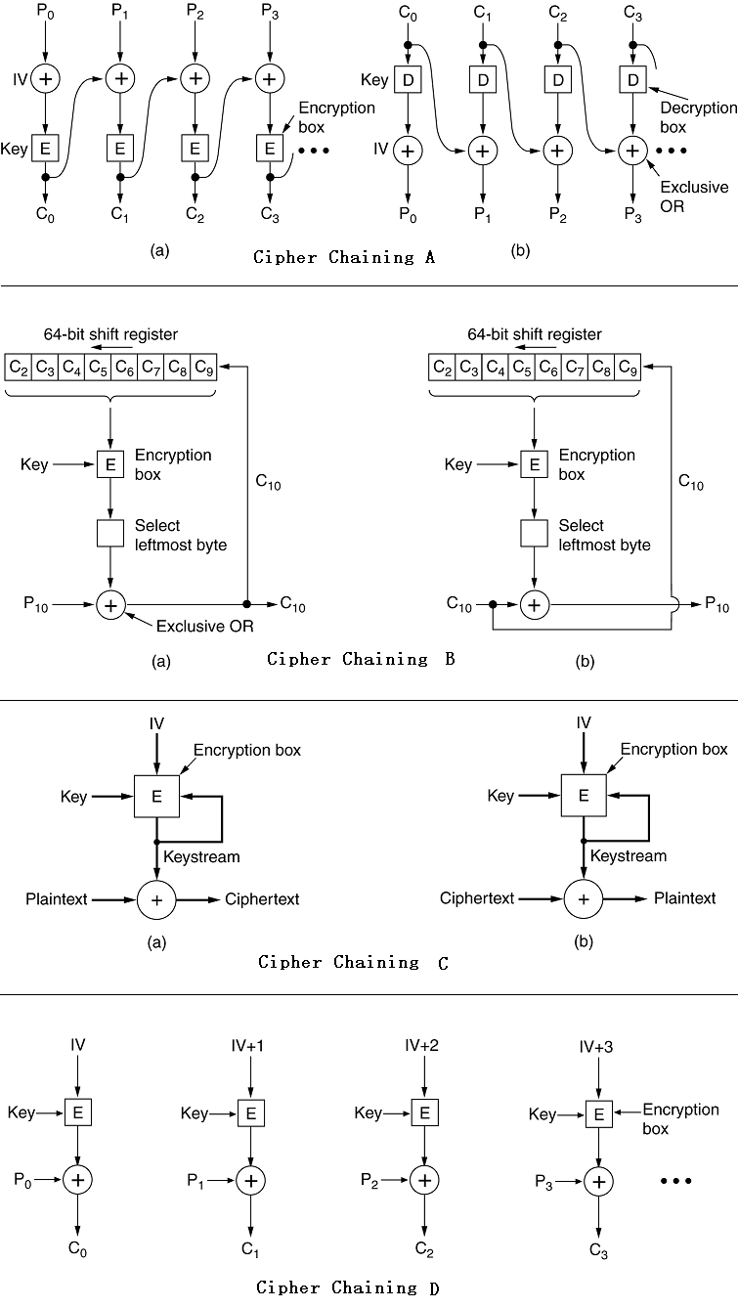
- Which mode is most suitable for use with interactive terminals?
  - Cipher chaining A
  - Cipher chaining B
  - Cipher chaining C
  - Cipher chaining D

- Which mode is most suitable for use with real-time streaming?
  - Cipher chaining A
  - Cipher chaining B
  - Cipher chaining C
  - Cipher chaining D

- Which mode is most suitable for use with disk files?
  - Cipher chaining A
  - Cipher chaining B
  - Cipher chaining C
  - Cipher chaining D

- Which of the following is the strongest symmetric-key encryption algorithm?
  - DES
  - AES
  - RSA
  - MD5

- Which of the following is the strongest public-key encryption algorithm?
  - DES
  - SHA-1
  - RSA
  - MD5

Consider the figure shown below, which takes some plaintext as input and produces signed ciphertext in some ASCII format as output. Please answer the next questions

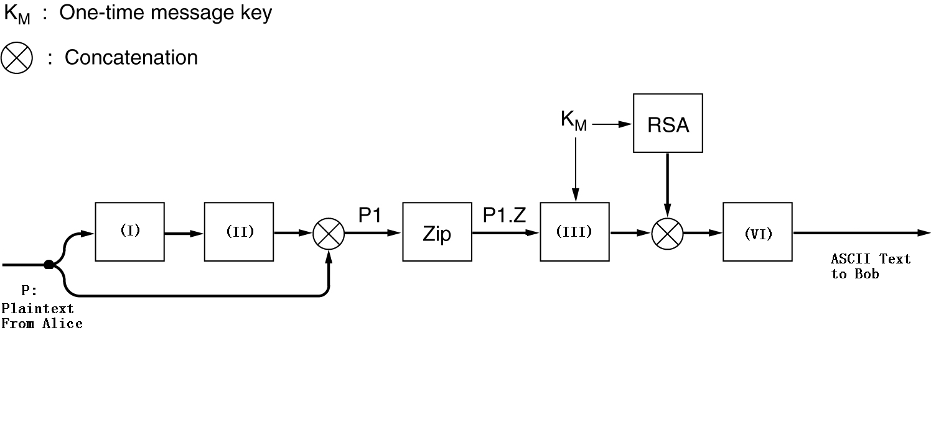
- Which of the following should be used for blank (I)?
  - DES
  - AES
  - MD5
  - None of the above

- Which of the following should be used for blank (II)?
  - RSA with Alice’s private RSA key
  - RSA with Alice’s public RSA key
  - RSA with Bob’s private RSA key
  - RSA with Bob’s public RSA key

- Which of the following should be used for blank (III)?
  - MD5
  - AES
  - SHA-1
  - Base64 encoding

- Which of the following should be used for blank (IV)?
  - MD5
  - AES
  - SHA-1
  - None of the above

